DRAFT: 9 Sep 2013

**Slum Types and Adaptation Strategies:**

**Identifying Policy-Relevant Differences in Bangalore**

Anirudh Krishna

(Duke University)

M.S. Sriram and Purnima Prakash

(Indian Institute of Management, Bangalore)

*Paper presented at an international workshop on “Living in Low-income Urban Settlements in an Era of Climate Change,” organized by the Brooks World Poverty Institute and the University of Manchester, UK (September 9-10, 2013)*

Abstract

An empirical analysis of the lived experiences of more than 2,000 households in different Bangalore slums shows how migration patterns, living conditions, livelihood strategies, and prospects for the future vary widely across distinct types of slums, initially identified from satellite images studied over a ten-year period. Shocks and responses vary in nature and intensity; coping and accumulative strategies diverge across slum types. More fine-grained policy analyses recognizing this diversity of slum types will more effectively help people deal with shocks and raise resilience.

Official and scholarly attention has grown rapidly in recent years as slums have continued to expand across Indian cities. For the first time, in 2011, the Census of India presented separate estimates of the population in slums.[1] Reports from other official agencies have added knowledge about slums and slum dwellers.[2] Whereas previously scholarship was mostly focused on rural poverty, more recent scholarly investigations have focused on conditions of poverty in urban slums. Considerable gaps in knowledge remain, however. Among these gaps the three described below are especially important:

* *Unhelpful typologies and shaky estimates*: Official agencies acknowledge only two broad types of slums. There is first a category of officially-declared (“notified” or “recognized”) slums, and then there is a second omnibus category which, by including all other low-income settlements, is hardly ever accurate or complete.[3] Vast differences characterize the conditions of life between slums of different types, and these differences are poorly captured by these gross distinctions. Notified slums differ from one another depending upon their age and location. Even larger differences exist within the more unwieldy and unproductive category of non-notified slums.

Diverse estimates of the number of slums and the size of the slum population have been produced by government agencies with different views about what constitutes a slum. The Census of India defines a slum as “a compact area of at least 300 population or about 60-70 households of poorly built congested tenements, in unhygienic environment usually with inadequate infrastructure and lacking in proper sanitary and drinking water facilities.” However, the Ministry of Housing and Urban Poverty Alleviation, following the definition adopted by the National Sample Survey Organization (NSSO), considers as a slum “a compact settlement with a collection of poorly built tenements mostly of a temporary nature, crowded together usually with inadequate sanitary and drinking water facilities in unhygienic conditions. Such an area, for the purpose of this survey, was considered ‘non-notified slum’ if at least 20 households lived in that area. Areas notified as slums by the respective municipalities, corporations, local bodies or development authorities are treated as ‘notified slums’” (GOI 2010: 3).

Not surprisingly, given these differences in definitions and minimum qualifying size – at least 60-70 households in the Census definition and only 20 households in case of NSSO – and on account of other differences in enumeration techniques, widely varying estimates have been offered. For example, the NSSO and the Ministry of Housing and Urban Poverty Alleviation estimated in 2009 that 16.5 percent of the urban population of Karnataka lived in slums, but only two years later the Census came up with a figure of 12.2 percent.

Along with the uncertainty about the “true” size of the slum population, another complication is given rise by these official definitions. In both definitions, that of the Census and that of the Ministry, there is a common conception that slums are constituted by “poorly built tenements mostly of a temporary nature.” These definitions apply poorly or not at all to many slums settlements, particularly officially notified ones, within many of which it is common to find concrete multi-storied buildings. There are, of course, other types of slum settlements, closer to the official definition, in which homes are no more than four rickety poles supporting a roof made of rough plastic sheets. But this type of slums is lumped together in official listings with other such non-notified slums, among which many have progressed along the path toward permanent buildings.

Little is gained (and much is lost) by considering slums as a homogenous category of settlements or even by sticking to the gross distinction between notified and non-notified types. Constructing better subordinate classifications is necessary for developing more useful and cost-effective policy interventions.

* *Missing boundaries*: Even when a slum is notified or recognized by a municipal authority (or identified by census or NSSO enumerators) the spatial boundaries of these settlements are rarely, if ever, plotted on city maps. Slums sprawl over time, stretching their original (unrecorded) boundaries, and new constructions in these spaces remain in legal limbo. Other slums, particularly the flimsiest ones, are simultaneously dismantled or relocated. The landscape of slums is ever-changing, but plotting their locations on a map is largely a product of guesswork.
* *No longitudinal information*: Resurveys of slum households to ascertain directions of movement – have households in slums improved their economic positions over the years or have these positions deteriorated for many of them? – are virtually unknown. As a result it becomes hard to ascertain whether some particular sets of policies have actually helped or whether a different set of supports will provide more bang for the public buck.[4]

Each of these concerns is being addressed by a research project that we commenced in 2010 in Bangalore in collaboration with the non-profit agency, *Janalakshmi*, which has for many years provided financial services to low-income populations in Bangalore. It has more recently widened its scope and now provides housing and other social services to these population groups (www.janalakshmi.org).

Comparing high-resolution satellite images over a ten-year period, supported by extensive verifications on the ground and detailed household surveys, helped distinguish initially between four types of slums.[5] We present here a comparison between the poorest and best-off slums, leaving the middle categories, within which investigations are currently ongoing, for a later discussion. Techniques and investigation protocols developed for Bangalore can help address similar needs within other cities.

**Methods: Satellite Imagery with Iterative Ground-verification Exercises**

Despairing of this poor state of knowledge, particularly about slums locations and boundaries, investigators have turned recently to remote-sensing techniques.[6] Our work in Bangalore extends this trend, relying upon Google Earth images compared over a ten-year time horizon, to assist with the following objectives.

(a) Identifying low-income settlements and detecting newly arisen slums

(b) Tracking changing slum boundaries

(c) Distinguishing types of slums

Since home addresses within slums, even longstanding ones, are notoriously hard to locate, with street names and street alignments changing frequently, we are additionally

(d) Geo-referencing sample households with the intention of re-interviewing them at regular intervals in the future.

The decision to explore Google Earth images was taken after undertaking an initial round of surveys in 2010. These investigations were conducted within 14 slum settlements, randomly selected from the list of notified slums provided by the Karnataka Slum Development Board (KSDB), the official agency in charge of slums in the state of Karnataka, of which Bangalore is the capital city.

Detailed interviews with 1,481 households living in these 14 settlements showed how slums on the official list represent the pinnacle of a vast iceberg, home not so much to the poorest people as to a settled lower-middle class, most of who have lived in Bangalore for multiple generations. This type of slums is furthest from the official definition. Permanent constructions prevail; electricity connections and clean drinking water are commonly available. These slum residents are firmly anchored within the city economy, providing a variety of services, mostly in the informal sector. Poverty is low in comparison to the average for the city, with 14 percent of residents reporting incomes below the official line as against the figure for 26 percent estimated for urban Karnataka by the officially-appointed Tendulkar Committee. In terms of assets, as in terms of income and poverty prevalence, slum dwellers are located near the middle of the socio-economic spectrum of this city. Kerosene or gas stoves are owned by nearly every household. Television sets, pressure cookers, and electric fans are the next most common asset types, with more than 80 percent of all slum households reporting ownership. Mobile phones are owned by more than two-thirds of these households. Investment in education ranks alongside home ownership as these households’ highest spending priority. Nearly all children go to schools, with most staying all the way through high school (Krishna 2013).

Hardly anyone in this type of slums is newly arrived in Bangalore; the vast majority was born in this city. In no more than 152 households – a little over 10 percent of all interviewed households – is the adult male (or female) a first-generation migrant. A total of 147 households (10 percent) are second-generation Bangalore residents, another 131 (9 percent) are third-generation residents, while the largest proportion, more than 70 percent, have lived in Bangalore for *four or more* generations.

So where do new migrants go when they come to Bangalore, as so many do year after year? Where do the poorest people in Bangalore live, if not in slums? How does one locate these types of places? Since existing data sources are of little help, new and reliable methods of data collection need to be developed.

We began our exercise of identifying low-income settlements by drawing the spatial borders of the area administered by the municipal authority, the *Bruhat Bangalore Mahanagara Palike* (BBMP).[7] This area was divided into four equal-sized quadrants on a map of Bangalore drawn on Google Earth.[8] Considering each quadrant separately helped analyze a more manageable number of identified settlements (polygons), enabling ground verifications to be made quadrant-by-quadrant.

We found that examining images at an altitude of 4,000 feet was most helpful for our purposes, and we compared settlements at the same height level on Google Earth. Google Earth’s time range of data varies. For most settlements, there are satellite images starting in 2000. However, some only have images dating back to 2002 or 2004. Similarly, the vast majority has an updated 2011 image, but some only some have images dating to 2010. In order to generate comparable data, the first year with a satellite image was referred to as the “initial year” and the most recent year with a satellite image is referred to as the “final year,” allowing us to measure averagechanges per year in settlement size, housing stock quality, and housing density.

Based on the following initial identification criteria, 279 low-income polygons were identified at the start: lack of space between blocks;[9] roofs that appeared to be low-quality based on brown or weathered grey coloring; a hodgepodge pattern of blocks; lack of proper roads (if there are roads, they are brown, narrow and unpaved); and lack of shadows adjoining the blocks, signifying that they are low to the ground, thus not multi-storied. A unique name was provided to each such polygon based on the nearest named populated place or water body. Iterative ground verification exercises led to continuous improvement in our ability to accurately delineate low-income and very-low-income settlements and to exclude better-off communities (including notified slums).

Successive iterations led us to conclude that by far the most important criteria for determining whether an area is low or very-low income are:

* Small block sizes and
* Lack of space between blocks

As supporting criteria the following were found useful: unpaved roads, if they are visible (however, paved roads are not an indication that a settlement is not low-income); narrow inner roads, if visible on these images;[10] and brown-roofed blocks.

Before finally operationalizing these stripped-down criteria, we looked again at satellite images of settlements that we had categorized as very low-income side-by-side with those categorized as low (but not very low). Figures 1A and 1B show one example of each type. On-the-ground verifications of these and other identified low- and very-low-income settlements showed that our criteria are reliable in distinguishing between these two types of slums.

- Figures 1A and 1B about here -

A third and lowest-income category of settlements was identified based on our initial rounds of field visits, when we understood that new settlers live mostly in temporary settlements and that the color of these roofs is rarely grey or brown. Homes within these newer settlements are in general covered by blue plastic sheets (referred to as tarpaulins, but made of plastic based material).[11] The recurrent observations that temporary settlements tend to have blue-colored roofs provided us with a different set of criteria for identifying the poorest settlements. In exploring these settlements, we used the time slider feature on Google Earth and began noticing that these settlements had come up in the most part within the past few years, although some have been around for much longer, growing in size over the ten-year period observed.

The ground-truthed criteria that we used for identifying such first-generation settlements on satellite images were the following:

* small block size
* blue roofs
* established or expanded recently

Figures 2A-2C show examples of settlements of this type were identified. The comparisons presented of before-and-after satellite images provide indication of the rapid pace of transformation that is bringing into existence ever-growing numbers of this type.

- Figures 2A, 2B, and 2C about here -

We identified 61 such settlements in all, and our ground-verification exercises showed how these initial identifications were accurate in the vast majority of cases. A total of 8 settlements no longer exist, either because they have relocated or because of an error in identification. It is also likely that some newer settlements have come into being, which we were unable to identify because of satellite image data that do not go no beyond 2010. Thus, while our methodology is subject to the error of omission – i.e., not picking up recently established blue polygons, the error of commission, as we could make out from our ground verification exercises, is minimal; there were no false positives in these identifications

In all, therefore, three types of slum settlements – new migrants (blue polygons: Figures 2A-2C), very low income settlements (orange polygons: Figure 1A), and low income settlements (red polygons: Figure 1B) – were discerned through this process of analysis. Each of these three types is different in important respects from the other two types, and all of them are different from notified and recognized slums, the fourth type of Bangalore slum.

In the rest of this paper, we present a comparison between the two slum types that represent the extremes of this hierarchy – first-generation settlements (blue polygons) and fourth-generation slums, the notified list of KSDB. Since detailed field surveys including household interviews have only recently been commenced in the other two types of settlements (red and orange), we have little further to say in this paper about these two types of slums, except to remark that the distinctions detected between them have proved robust in field verifications.

**First-Generation Slums: “We are only here to settle our village debts”**

First-generation slums – blue polygons – are home to recent migrants from rural areas, mostly from northern Karnataka and the adjoining state of Andhra Pradesh, although a few have come from as far away as West Bengal and Uttar Pradesh. Residents of these slums retain strong links with their native villages, going back and forth often, with many families split between the two locations.

The development of this type of slum is in considerable part a response to diminished and uncertain rural livelihoods. Reasons for coming to the city are implicated primarily in agrarian crises brought on by droughts and erratic rainfall and the consequent need to pay off accumulated debts.

The typical abode is a 7’x7’ tent erected on land hired from a private owner. Families of between 3 and 5 individuals share these meager spaces, with a large majority of adults (male and female) and many older children employed as construction labor. Indeed, some among these settlements are construction sites, while some others, pending the grant of building permits, instead of lying vacant, have been let out temporarily to migrants, earning rent for their owners. Occupants pay rent for every month they are allowed to remain, never knowing when they might be evicted. The monthly rental figure for one of these tiny plots ranges from Rs. 200-400, with migrants from further afield paying considerably higher amounts. These amounts are paid in cash and “under the table; there are no receipts and certainly no written leases.

We undertook detailed investigations in a randomly selected sample of 18 first-generation settlements of this type between August and December 2012, conducting interviews with a total of 631 households, a little more than half of all households then living within these settlements. We selected households for interviews following a process of random selection (picking every second household starting from a common point), although in a few cases these protocols were breached, since contact with some households proved impossible despite repeat visits. Residents tended to be suspicious of outsiders. Appeals to local leaders or the owners of these lands were often necessary in order to gain entry. But once the initial doubts were allayed, interviews proceeded with ease. There were hardly any refusals.

On average, 70 households – most having migrated from the same rural village or adjoining group of villages – constitute a first-generation settlement, with settlement sizes ranging from 10 to 150 households. About 40 percent of households came to Bangalore between one and five years ago, and another 40 percent have been in this city for between five and ten years, with a smaller proportion, about 15 percent, having stayed in Bangalore for more than ten years.

Prior to coming to the city the principal occupation of a little more than one-half, 52 percent, of residents was agricultural labor. Another 40 percent farmed small plots of land, supplementing these incomes with farm or off-farm labor. While primarily agrarian in origin, as many as 38 percent of these households own no agricultural land of their own, another 34 percent own tiny plots of between one and three acres, with only 7 percent owning five or more acres of agricultural land.

A large majority of these residents, 72 percent, belong to Scheduled Castes (SCs), the former untouchables – more than three times the share of this group in the population of Bangalore. Scheduled Tribes (STs), India’s aborigines, constitute another 11 percent. Other Backward Castes (OBCs) make up 7 percent of this group. In 8 of the 18 selected neighborhoods, SCs constitute 100 percent of the settler group. Table 1 provides these details for all 18 neighborhoods.

- Table 1 about here -

Their caste backgrounds, land holdings, and prior occupations show how this group of households comes from among some of the poorest people in rural India, impelled to move from their native villages by the diminishing economic prospects that have been brought on, in the longer term, by fragmenting landholdings, and in the immediate term by debts and droughts and climate changes. More than 80 percent cited droughts, debts, and the general difficulty of making a living in their native villages as their principal reason for making the trek to the city.

These impressions are strengthened when one considers other aspects of lifestyle including current occupations and asset holdings. Men and women work on construction sites as irregular, daily-waged, labor, with men earning, on average, Rs. 300 for each day’s work, and women, earning lower amounts, around Rs. 200, even when they do the same kinds of work.

Few possessions are visible within these 7’x7’ tent dwellings: shabby clothes strewn about or stored on wooden planks that are balanced atop brick or earthen supports; three or four battered aluminum cooking vessels; an open wood-burning *chulha* (fireplace); a mobile phone to stay connected with the family in the village; pictures of Hindu gods and goddesses; and one or two plastic containers in which water, brought from afar, is stored.

Blue-polygon settlements exist in an institutional vacuum, unconnected to city services and unconnected as well to sources of economic opportunity and social mobility prospects. None of these 18 settlements is connected to the electricity network. Not one is served by street lights. Darkness after sunset, combined with muddy, narrow, twisting and unpaved alleyways and the frequent presence of vicious bands of stray dogs, made it imperative to complete household interviews early, immediately after householders returned from a day of work. A hand-pump in one neighborhood and a bore-well in another neighborhood serve as the exceptions; residents of the remaining 16 neighborhoods purchase the water they consume from mobile tankers or they travel great distances to fill up at public water points. Garbage removal and security services are unknown. The nearest public bus stop is located within one kilometer of only two settlements and it is more than three kilometers from another nine settlements. The nearest health clinic, government or private, is four kilometers distant, on average. There are no signs visible in any neighborhood of ongoing government, NGO or other outside supports.

People here are generally left to cope on their own. They rely only upon immediately family or neighbors for support. Our interviews revealed how in dealing with a variety of situations, of both an everyday and an emergency nature, only a tiny percentage has been able to call upon support from employers, community leaders, government officials, political parties, NGOs, or any other organized force.

Prospects for advancement and permanence are severely compromised on account of frequent absences, occasioned by visits two or three times a year to the native village. Such visits are necessary to look after the land and family left behind and to service the debts that originally brought one to Bangalore. Only 32 of 631 households (5 percent) did not visit their native villages even once during the 12 months preceding this survey. Another 157 households made one visit, 229 households made two visits, and the remaining 213 households made three or more visits to their native village in the year preceding these interviews. On average, 2.3 trips were made annually, with a total period of 32 days being spent in the native village. A great deal of expense was incurred on these visits as well as on monthly debt repayments. As many as 494 households, 80 percent of the total, have one or more debts outstanding in their home village. The average outstanding debt is Rs.116,800, with interest accruing at rates ranging between two and four percent monthly. More than two-thirds of all loans have been contracted from moneylenders, with about one-quarter coming from family and friends.

Repeatedly, these people informed us how they have come to the city with the main purpose of repaying the debts that their families and they have accumulated back in the village. Whatever they are able to save from what they make working as construction labor (the principal occupation of more than 80 percent of all male and female household heads) or as casual labor of other kinds goes into building a better life back in the village. Thus, opportunities for self-improvement in the city are passed by; they are neither actively pursued nor often even visualized as real possibilities.

Table 2 shows the distribution of average monthly expenditures for these blue-polygon households. More than one-quarter of this total goes toward meeting obligations connected with the native village, with 16 percent going toward debt repayment and another 12 percent toward travel and remittances. The average household sends to its native village a sum of Rs. 1,840 every month.

- Table 2 about here -

Notice in Table 2 how only a tiny proportion of the household budget, 4.8 percent, is spent on education. In fact, no more than 21 percent of all 631 households spends any amount whatsoever on tuition, fees, and other school-related expenditures. Very few children are sent to school.

- Table 3 about here -

Table 3 shows the distribution of educational attainment by age and gender. More than three-quarters (77 percent) of all household members aged 14 years or older have no formal education, having never been to school. More young people of school-going ages are out of school than attend schools regularly, and those who do attend school do so sporadically, dropping out for the most part after attending for only a couple of years. Those few young people who do attend schools regularly are the ones who have remained behind in the native villages. Partly as a consequence, the vast majority of education is conducted in local languages, with 75 percent and 16 percent, respectively, attending Kannada-medium schools and Telugu-medium schools. No more than 4 percent attend English-medium schools, an important point of difference with notified slums, in which the vast majority of young people attend regularly through high school, with more than 60 percent being given an English-medium education, the better to raise career prospects. The itinerant life that is lived by residents of blue-polygon slums along with their economic difficulties makes it hard for them to keep children at school.

Lack of official identity papers acts as a further deterrent. The papers that blue-polygon residents possess are related to their residence in their native village. Only a tiny proportion is registered in any way as a resident of Bangalore. Thus, 69 percent have a Voter ID card in their native village, but fewer than 9 percent are registered to vote in Bangalore. Similarly, 65 percent have a ration card issued in their native village, but only 6 percent have one in Bangalore. The corresponding proportions for a Unique ID (or *Aadhar*) card are 17 percent and 1 percent.

Not only getting children admitted to school but also availing themselves of any other social services or benefits in the city becomes nearly impossible in situations where people’s very existence is not recognized or registered by the city. The comparable situation in notified slums is very different, as we will see in the next section. Cut off from flows of social assistance as also flows of information and influence, blue-polygon residents eke out a meager living, surviving from day-to-day but hardly making any considerable progress from year to year.

Intergenerational occupational mobility is virtually non-existent. Principal occupations among current male heads of households are very much the same as they were for their fathers and grandfathers, the vast majority of who also hired themselves out as casual labor. The only difference is that while fathers and especially grandfathers scratched out a living by working as agricultural and coolie (plantation) labor in rural areas, current-day adults in blue-polygon slums work as casual construction laborers in Bangalore.

The small advances that they are able to make are quite often compromised by adverse events. Exposed to risk in two places – in their city tents as well as in their native villages – the lives of first-generation slum residents are doubly precarious. Along with droughts and rainfall failures, remarked upon earlier, deaths, marriages and health incidents combine to eat deeply into these households’ meager savings, making further debt necessary in the majority of cases. A total of 447 households (71 percent) reported experiencing a health incident requiring substantial expenditure (of Rs. 30, 285, on average) during the preceding year. Expenses on marriages added more than Rs. 100,000 over the prior five years to the outstanding debts of 391 households (62 percent).

Their livelihood patterns in the city, coupled with meager or non-existent policy supports, instead of enhancing resilience, place a low upper limit upon these people’s capacities. The threat of eviction is ever present. And yet, lacking alternatives, some among these shabby and easily dismantled settlements have been in place for ten years or longer, with the average age of settlements being a little more than 6.5 years. In contrast, notified slums represent, in general, a higher order of livelihood, not merely surviving from day-to-day but building assets and investing in education and skills – with many becoming a part of a lower middle class, a result of incremental gains won through a series of political gains and official accommodations.

**Comparing First- and Fourth-Generation Slums**

Diverse points of comparison – asset holdings, occupation types, aspirations and investments in children’s education, identity cards, cooking needs, vulnerability to natural disasters, etc. – make clear how first-generation migrants settled in blue-polygon areas constitute a very different population group compared to fourth-generation notified slum residents. Analyzing separately their compulsions and prospects helps make for a more nuanced and thus more effective slum policy.

In one respect, however, being in a slum, no matter of what type, has a similar rather than a different consequence. In the most part, slum residents, while living in the city, are only poorly connected to the kinds of institutions that make the city a source of economic dynamism for other population groups. Lack of information and lack of connection are common themes across diverse types of slum settlements. In other respects, however, understanding the differences that exist across diverse types of slums, and coming to grips with the sources of these differences, is both necessary and helpful for policy formulation. Figures 3 and 4 provide visual evidence of the contrasts that exist between these two types of slums.

- Figures 3 and 4 about here -

*Assets*

A household’s asset holdings provide one indication of its ability to withstand shocks without succumbing to poverty. Comparing the asset holdings of these 631 first-generation (blue polygon) slum dwellers with those of 1,011 fourth-generation residents (more than 70 percent of all residents interviewed in notified slums in 2010) provides one measure of the gulf separating these two types of slum.[12]

Hardly any fourth-generation resident of notified slums in Bangalore has any ongoing relation, economic or social, with a rural village. Their asset holdings like their sources of livelihoods are entirely contained within Bangalore. In contrast, first-generation blue-polygon residents divide their times and often also their families between the city and the native village. Table 4 reflects these divided livelihoods, considering, first, the asset holdings of blue-polygon resident in the city and then considering their combined assets in the city and the native village.

- Table 4 about here -

Notice how the asset holdings of fourth-generation slum residents dwarf those of first-generation migrants. More than 80 percent of fourth-generation residents possess televisions, electric fans and pressure cookers. The comparable percentages within the blue-polygon settlements are no larger than 1 percent in each case (with somewhat higher percentages prevailing if we were to consider combined asset holdings in the city as well as in the native village).

Different classes of people reside in these two types of slums. Considering home ownership in addition to these other assets further reinforces this impression. As many as 52 percent of fourth-generation residents own the homes in which they live, with most of them (85 percent) titles to the land and building. In contrast, not one blue-polygon resident owns a home in the city.

Asset building among notified slum dwellers, occurring incrementally, takes the form of acquiring first a home and the basic necessities, such as gas or kerosene stoves, pressure cookers, and electric fans. Interestingly, TVs are also acquired early in the process of asset acquisition. Apart from its entertainment value, television also serves as the primary source of information. Nearly 90 percent of notified slum residents rely upon television for their information needs.

Mobile phones – essential for keeping up with one’s customers, employers, and suppliers, and in the case of blue-polygon residents, also with families back in the native village – are also acquired early on by slum residents of all kinds. In this respect, a mobile phone is a very special kind of asset, whose possession is only loosely related to overall economic status. The cheapest available sets, with prepaid plans, predominate, especially with blue-polygon settlements.

One other big difference in assets, particularly related to environmental impacts, concerns the nature of domestic fuels used by first- and fourth-generation slum households. While nearly all fourth-generation households rely upon cooking gas or kerosene, all but one or two blue-polygon households collect or buy firewood for their cooking needs.

*Occupation Types*

What people do – and what their circumstances and backgrounds prepare them for doing – influence what they can accomplish by way of building assets and acquiring skills. A key point of difference between fourth- and first-generation residents relates to the places they occupy in the city’s economy. Table 5 brings out differences in the distribution of occupation types.

- Table 5 about here -

While first-generation residents work predominantly as casual labor in building construction, fourth-generation residents are distributed across a variety of occupations, with the largest share engaged as skilled and semi-skilled tradespeople, carpenters, electricians, and suchlike. Another large chunk of fourth-generation slum residents is employed as office clerks or security guards. Fewer than ten percent are employed in construction activities, constituting the lowest-paid and least secure part of the occupational spectrum.

Differences in female occupation (not reported in a separate table for want of space) reflect the differences seen above in the case of males, with the majority of blue-polygon females, 62 percent, being employed as casual construction labor or helpers in building activities, and only 12 percent of fourth-generation females being employed in similar trades. Younger fourth-generation females have made considerable gains compared to their mothers and grandmothers. After completing high school, they have gone on to work as shop assistants, call-center operators, and secretaries in offices. Education has served thus as a pathway to social mobility, albeit still of a limited kind. No notified-slum dweller in our sample of more than one-thousand has become a medical doctor, lawyer, senior government official, or MBA – and no young person is currently attending the kinds of educational programs that can prepare them for such careers.

Informal occupations predominate in both types of slums, but earning potentials are vastly different. People’s abilities to invest in their children’s futures are also considerably different.

*Education and Aspirations*

Notified-slum residents invest heavily in education and in the acquisition by their children of additional skills, particularly, English and computer knowledge. All but a very few children of school-going age attend schools regularly, girls as well as boys, going all the way up to and including high school. Boys usually get between ten and 15 years of formal education, with the median figure being 12 years. Girls, on the other hand, study on average for two fewer years, generally finishing school after 10 years of formal education. In contrast, the majority of school-age children in blue-polygon slums are out of school, and only a small minority get educated all the way to high school, and then, too, in schools where the medium of instruction is Kannada or Telugu.

Awareness of superior career possibilities is high among residents of notified slums, far higher than among residents of blue-polygon slums, the majority of whom were unable to state any particular career aspiration for their daughters and sons, and those who did state something definite in response to their question, mostly cited something vague and all-encompassing, such as “acquiring education” or “getting a job.”

In consequence, social mobility is virtually non-existent among residents of blue-polygon slums. Sons and daughters have followed mothers and fathers into the same kinds of low-skilled, low-paid, and precarious occupations, working in the village as agricultural labor and in the city as construction labor with no secure or reliable perch.

*Sources of Institutional Support*

Mitlin and Satterthwaite (2012: 396) assert how “those living in informal settlements have no influence on local government or service providers, who ignore them and their needs.” Their depiction adequately characterizes blue-polygon settlements and it applies in some part also to notified slums.

Not one blue-polygon resident has benefit from a job training or skill development program run by any government agency or NGO. Even in notified slums, fewer than ten percent of all currently employed fourth-generation residents were able to avail themselves of any vocational training or skills building programs, with the rest, more than 90 percent, learning the trades they practice through informal apprenticeships taken up with parents, relatives or friends. Information about career alternatives is obtained through word-of-mouth; no employment exchanges or career counselors are at hand.

Migrants when they first come into the city are rarely served by any government agency, or for that matter, any NGO. Those who obtained assistance did so in the most part from friends and relatives. When preparing for retirement and old age, 99 percent of slum dwellers expect to rely only upon immediate family, relatives, and friends. Less than one percent expected to receive any help from any government agency or NGO.

Slum dwellers do not actively wish to remain aloof from public institutions; that is not an explanation which this body of evidence supports. Given a choice, the largest number of slum residents want to engage actively with public institutions, also obtaining from them assistance and advice of different kinds. They want better schools, educational and housing loans on reasonable terms, vocational training, career guidance, and infrastructure improvements. But very few have actually received assistance in any of these forms.

Within notified slums, most residents have voter IDs and ration cards – another point of difference with blue-polygon residents – and some have safe drinking water supplies, but access to other financial, social and educational facilities remains weak overall. We asked a number of questions about the nature of connections they have made or which they would wish to make with government and non-government agencies. In each case their responses were strongly suggestive of impoverished networks and weak institutional connections.

People rely for the most part upon their individual social networks, but these networks are poorly endowed with resources and connections. In terms of helping facilitate connections with people who have any real influence – such as doctors, lawyers, elected officials, newspaper reporters, policemen, and factory owners – these existing social networks have very little value. We asked our respondents about whether they felt they would be able to connect with any of these (and other) people with influence. As many as 70 percent in notified slums and 95 percent in blue-polygon settlements mentioned that they would not be able to connect with even one individual of these different types. Their social networks, the individuals with whom they can consult on a regular basis – relatives, friends, and neighbors – provide them with all the job-related knowledge and professional connections that they are generally able to muster. Once again, institutions do not stand in support of individuals’ goals. Studies conducted in other slum settlements, in India and elsewhere, show how this situation may not be peculiar to Bangalore slums.[13]

**Conclusion**

The population of urban slums has been expanding rapidly in India. Two separate processes, with different internal dynamics and consequently diverse repercussions for policy, have contributed to this growth.

One part of the increase has come about through natural processes: births occurring within slums, outpacing deaths, have resulted in a natural process of population growth. This process is most prevalent within longer-established slums, and it was particularly visible in our surveys of notified slums, where the majority of residents, more than 85 percent, born within slums, have continued living there, incrementally building better lives and adding to asset holdings.

But there is also a separate process that is adding to slum populations, which is playing out more often at the lower end of the slum hierarchy. It is bringing first-generation migrants into the newest and flimsiest settlements, where poverty, uncertainty, risk, and vulnerability are more centrally implicated in people’s lives and livelihoods, and where resilience is much lower in comparison to notified slums. Longer-term diminution of economic prospects in agriculture coupled with the lure of growing cities has contributed to this process (Reddy and Mishra 2009), but so, too, have factors associated with changing climatic conditions. The largest proportion (81 percent) of our blue-polygon interviewees stated that their principal reason for coming to Bangalore was related to the increasing frequency of rainfall failures resulting in droughts, difficult working conditions in the village, and accumulating debts. As climate impacts add further to the precariousness of rural livelihoods, more such settlements can be expected to be given rise.

Currently organized helter-skelter, wherever niches are temporarily available, the kinds of settlements that currently serve as home in Bangalore to new migrants from distressed villages hardly serve as the loci for building a better life. Such people live within a narrow cocoon formed by fellow settlers and migrants whose lives are equally devoid of prospects for substantial improvement. They have no papers in Bangalore and no fixity of tenure, liable to be evicted, as many of our interviewees have been, with very little notice. Given these circumstances, these families aim not so much to build a better life within Bangalore as to use Bangalore as a means for paying off the debts that they have contracted in the village. Children’s education is given short shrift in the face of other more compelling and immediate commitments. Home improvements are neither feasible given that there is little left over after sending money back to the village, nor are such improvements desirable in situations where the threat of eviction is ever-present.

These situations contrast starkly with those experienced by native-born Bangaloreans living in notified slums. Home ownership and children’s education are the two highest priorities of people living in these other kinds of slums. There is no real threat of eviction for these residents, and the need to send remittances to other places is also non-existent for all but a very few.

Given these differences in current lifestyles and future expectations, different kinds of policy supports are required by people in different kinds of slums. Notified-slum residents will benefit most from receiving supports that can help raise social mobility, enabling their children to become, not only security guards and shop assistants, as so many have, but also to become medical doctors, software engineers, senior business professionals, and the like, positions not so far achieved by any but a tiny few. Notified-slum households are investing heavily in education, but the returns on these investments are currently low.

In contrast, blue-polygon settlers have a very different set of expressed needs and hopes regarding public assistance. Their basic needs – electricity, clean drinking water, security of person and property, education, secure housing, affordable health care – are largely unmet or require large expenditures.

Lacking identity papers in the city (and not registered as constituents or voters), blue-polygon dwellers have not been able to attract much political patronage or official support. Drives to acknowledge and register their presence in the city will, therefore, have to take precedence. Subbaraman et al. (2012: 661), who have intensively studied one such settlement in Mumbai, focusing primarily on health outcomes, underline how such slums constitute a “legal ‘no-man’s land’ − a zone absent of policies that address their existence as human beings and citizens of the city,” and they “emphasize the need to establish minimum humanitarian standards for …basic services such as water, sanitation, solid waste collection and restitution after calamities.” New forms of school instruction designed specifically for the itinerant nature of migrant families’ lives also need to be explored.

Helping first-generation migrants tide over the low-level obstacles they face both in the city and in their native villages will open the door to the possibilities of building a better life. Whether this can be done better by helping make rural livelihoods more bountiful and reliable, or whether – since cities are where Indian planners are pinning their future hopes[14] – it makes better sense to deploy public resources in building urban infrastructures for them is a critical question, one to which we doubt there is any unambiguous response.

So far mostly lacking, the effort to develop complete slums maps – with clearly marked boundaries and with settlements classified in terms of a clearer typology – must be taken forward vigorously. The methods presented here represent a useful starting point. They have proved productive in Bangalore, but how far they will be useful, with and without modifications, in other large and small Indian cities remains to be seen. In Bangalore, at least, the existence of substantial differences between the two types currently studied through detailed neighborhood studies combined with extensive household interviews shows that treating slums as a homogeneous category can result in serious policy mistakes.[15]

**References**

Banks, Nicola. (2008). “A tale of two wards: political participation and the urban poor in Dhaka city.” Environment and Urbanization, 20 (20).

Bapat, Meera. (2009). “Poverty Lines and Lives of the Poor: Under-estimation of urban poverty – the case of India.” Working Paper. London, UK: International Institute of Environment and Development.

Bhatia, N. and Chatterjee, A. (2010). “Financial Inclusion in Slums of Mumbai”. *Economic and Political Weekly*, October 16, pp. 23-26.

GOI. (2010). *Report of the Committee on Slum Statistics/Census.* New Delhi: Government of India, Ministry of Housing and Urban Poverty Alleviation. Available at <http://mhupa.gov.in/W_new/Slum_Report_NBO.pdf>

Harris-White… (2013)… ADD

Jha, S., Rao, V. and Woolcock, M. (2007). “[Governance in the Gullies: Democratic Responsiveness and Leadership in Delhi’s Slums](http://www.sciencedirect.com/science?_ob=ArticleURL&_udi=B6VC6-4MT59F2-1&_user=38557&_coverDate=02%2F28%2F2007&_alid=1526131764&_rdoc=2&_fmt=high&_orig=search&_origin=search&_zone=rslt_list_item&_cdi=5946&_sort=r&_st=13&_docanchor=&view=c&_ct=2&_acct=C000004358&_version=1&_urlVersion=0&_userid=38557&md5=ca715ede0e9205a34f96ac1ff5cfe720&searchtype=a).” *World Development*, 35 (2), 230-46.

Kit, Oleksandr, Lüdeke, Matthias, and Diana Reckien. (2013). “Defining the Bull's Eye: Satellite Imagery-Assisted Slum Population Assessment in Hyderabad, India.” *Urban Geography,* 34 (3): 413- 24.

Krishna, Anirudh. (2013). “Stuck in Place: Investigating Social Mobility in 14 Bangalore Slums.” *Journal of Development Studies,* 49 (7): 1010-28.

Livengood, Avery and Keya Kunte. (2012). “Enabling Participatory Planning with GIS: a case study of settlement mapping in Cuttack, India.” *Environment and Urbanization,* 24 (1): 77-97

Mitlin, Diana and David Satterthwaite. (2012). “Editorial: Addressing Poverty and Inequality; New Forms of Urban Governance in Asia.” *Environment and Urbanization,* 24 (2): 395-401.

Mitra, Arup. (2006). “Labour Market Mobility of Low Income Households.” *Economic and Political Weekly*, May 27, pp. 2123-30.

Mitra, Arup. (2010). “Migration, Livelihood and Well-being: Evidence from Indian City Slums.” *Urban Studies*, 47 (7): 1371-90.

NSSO. (2003). “Conditions of Urban Slums: Salient Features, NSS 58th Round (July 2002-December 2002).” Government of India: National Sample Survey Organization.

NSSO (2009). “India - Urban Slums Survey: NSS 65th Round: July 2008- June 2009.” Government of India: National Sample Survey Organization.

Ramachandran, H. and Subramanian, S.V. (2001). “Slum Household Characteristics in Bangalore: A Comparative Analysis (1973 and 1992),” in H. Schenk (ed.), *Living in India’s Slums: A Case Study of Bangalore*, pp. 65-88. New Delhi: Manohar Publishers.

Reddy, D.N., and Srijit Mishra. (2009). “Agriculture in the Reforms Regime,” in Reddy and Mishra, eds., *Agrarian Crisis in India*, pp. 3-43. New Delhi: Oxford University Press.

Roy, Manoj, David Hulme, and Ferdous Jahan. (2013). “Contrasting Adaptation Responses by Squatters and Low-Income Tenants in Khulna, Bangladesh.” *Environment and Urbanization,* 25 (1): 157-76.

Subbaraman, Ramnath , Jennifer O’Brien, Tejal Shitole, Shrutika Shitole, Kiran Sawant, David Bloom and Anita Patil-Deshmukh. (2012). “Off the Map: The health and social implications of being a non-notified slum in India.” *Environment and Development,* 24: 643-63

Sudhira, H.S., Ramachandra, T.V. and K.S. Jagadish. (2004). “Urban Sprawl: Metrics, Dynamics, and Modeling using GIS.” *International Journal of Applied Earth Observation and Geoinformation,* 5: 29-39.

TABLE 1: FIRST-GENERATION SETTLEMENTS: SCs, STs, and non-Hindus

|  |  |  |  |  |
| --- | --- | --- | --- | --- |
| Neighborhood | Household Count | SC | ST | Muslim or Christian |
| Quadrant I, Polygon-Hudi | 80 | 50 | 30 |  |
| Quadrant I, Polygon-Whitefield A | 35 | 35 |  |  |
| Quadrant IV, Polygon-HSR Layout A | 150 | 90 | 60 |  |
| Quadrant II, Polygon-Peenya Phase B | 60 | 50 | 10 |  |
| Quadrant II, Polygon-Chikka Venkatappa Lay out | 10 | 6 | 4 |  |
| Quadrant I, Polygon-Nagavarapallaya B | 15 | 15 |  |  |
| Quadrant I, Polygon-Manyata Residency | 160 | 120 | 30 |  |
| Quadrant II, Polygon-Atturu | 60 | 60 |  |  |
| Quadrant II, Polygon-Goraguntepalya | 25 | 25 |  |  |
| Quadrant III, Polygon-Bangarapanagar A | 60 | 45 |  | 15 |
| Quadrant III, Polygon-Bangarapanagar B | 25 | 5 | 20 |  |
| Quadrant III, Polygon-Kenchenhalli | 18 | 18 |  |  |
| Quadrant III, Polygon-RNS Inst. of Technology | 80 | 80 |  |  |
| Quadrant IV, Polygon-Kaikondrahalli | 58 | 58 |  |  |
| Quadrant IV, Polygon-Manjunatha | 150 | 75 |  | 30 |
| Quadrant IV, Polygon-Thubarahalli | 70 | 60 |  | 10 |
| Quadrant IV, Polygon-Nallurhalli | 130 | 100 |  | 15 |
| Quadrant IV, Polygon-Pattandur Agrahara | 50 | 50 |  |  |
| TOTAL | 1236 | 942 | 154 | 70 |

TABLE 2: MONTHLY HOUSEHOLD EXPENDITURES IN FIRST-GENERATION SLUMS

|  |  |  |
| --- | --- | --- |
| Category | Average monthly expenditure (Rs) | Share of total expenditure (%) |
| Food | 4349 | 57.3 |
| School fees and tuition | 361 | 4.8 |
| Medical | 703 | 9.3 |
| Debt repayment | 1,246 | 16.4 |
| Travel and remittances | 935 | 12.3 |
| Total | 7,593 | 100.0 |

TABLE 3: EDUCATION IN FIRST-GENERATION SLUMS

|  |  |  |  |  |  |  |  |  |  |
| --- | --- | --- | --- | --- | --- | --- | --- | --- | --- |
| Education (in years) | 0-6 years | | | 7-14 years | | | > 14 years | | |
| Male | Female | Total | Male | Female | Total | Male | Female | Total |
| 0 (No education) | 29 | 32 | 61 | 63 | 93 | 156 | 715 | 792 | 1507 |
| 1-7 | 46 | 32 | 78 | 126 | 134 | 260 | 165 | 59 | 224 |
| 8-12 | 0 | 0 | 0 | 34 | 21 | 55 | 156 | 60 | 216 |
| Higher Education | 0 | 0 | 0 | 0 | 0 | 0 | 1 | 1 | 2 |
| Total | 75 | 64 | 139 | 223 | 248 | 471 | 1037 | 912 | 1949 |

TABLE 4: ASSET OWNERSHIP

(percent of households owning each type of asset)

|  |  |  |  |
| --- | --- | --- | --- |
| Asset Type | Fourth-generation residents (notified slums) | First-generation residents  (blue polygons) | |
| In Bangalore | Bangalore or Native Village |
| Kerosene or Gas Stove | 98% | 7% | 11% |
| Television | 84% | 1% | 22% |
| Electric Fan | 84% | 1% | 24% |
| Pressure Cooker | 81% | 1% | 3% |
| Dressing Table or Almirah | 43% | 0% | 6% |
| DVD or CD Player | 22% | 0% | 6% |
| Bicycle | 18% | 6% | 22% |
| Motorcycle or Scooter | 17% | 3% | 5% |
| Refrigerator | 6% | 0% | 0% |
| Sewing Machine | 6% | 0% | 1% |
| Washing Machine | 4% | 0% | 0% |
|  |  |  |  |
| Mobile Phone | 81% | 75% | 82% |

TABLE 5: DIFFERENCES IN PRINCIPAL OCCUPATIONS (Males)

|  |  |  |
| --- | --- | --- |
| Occupation Types | Fourth-generation residents (notified slums) | First-generation residents  (blue polygons) |
| Agriculture | - | 4% |
| Carpenter/Electrician/Plumber | 24% | 2% |
| Security Guard | 11% | - |
| Office Clerk | 10% | - |
| Construction worker/Coolie | 9% | 68% |
| Home-based business | 7% | 4% |
| Vegetable, flower, or fruit seller | 6% | 2% |
| Shop assistant | 9% | - |
| Factory worker | 5% | 2% |
| Commercial driver | 3% | - |
| Teacher | 3% | - |
| Personal driver | 1% | 1% |
| Tailoring/Embroidery | 1% | - |
| Shop owner | 1% | 2% |
| Unemployed and looking for work | 3% | 11% |

FIGURE 1A: Very Low Income Settlement: Khata Nagar A

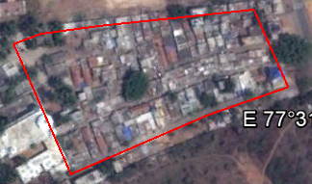

Two Main Google Earth Criteria: Small Block Sizes, Lack of Space between Houses

Supporting Criteria: Paved Roads, Narrow Inner Roads, Small Brown Roofs

FIGURE 1B: Not Very Low Income Settlement: Kodigehalli

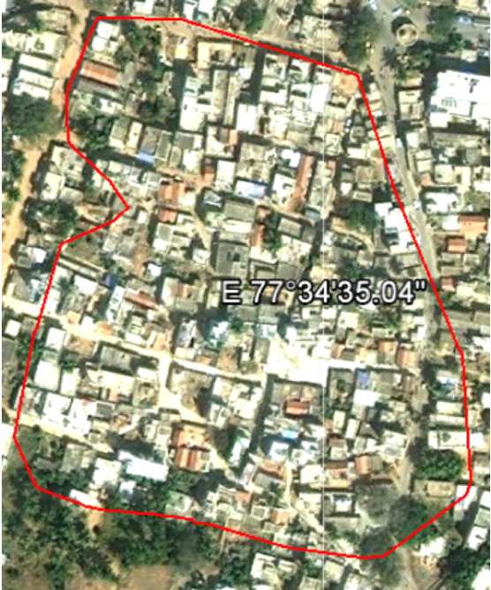

Two Main Google Earth Criteria: Medium Block Sizes, Plenty of Space between Houses

Supporting Criteria: Paved Roads, Inner Roads Somewhat Narrow, Some Small Brown Roofs

|  |
| --- |
| FIGURE 2A: Example of finding a blue polygon: Quadrant II, - Atturu from 2005 to 2010 |
| FIGURE 2B: Quadrant IV, Manjunatha Layout A* & B* from 2009 to 2010. Ground verification in 2013 showed that these two blue polygons had merged, constituting a large pool of blue tarps (bottom panel) |

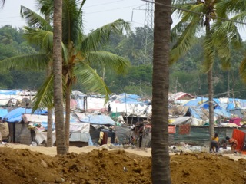

|  |
| --- |
| Screen Shot 2012-07-19 at 11.26.16 AM.pngFIGURE 2C: Quadrant I - Hudi from 2002 to 2010  Screen Shot 2012-07-19 at 11.26.27 AM.png |

FIGURE 3: Example of a blue-polygon settlement

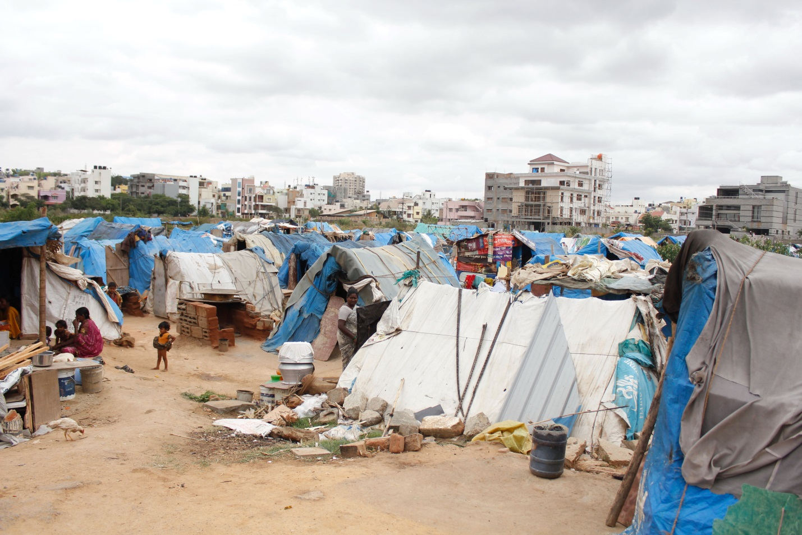

FIGURE 4: Examples of notified slums

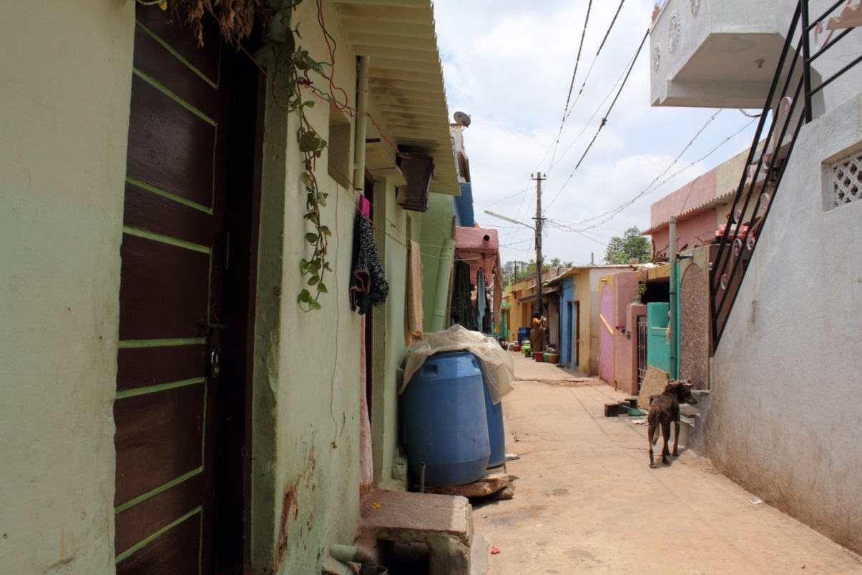

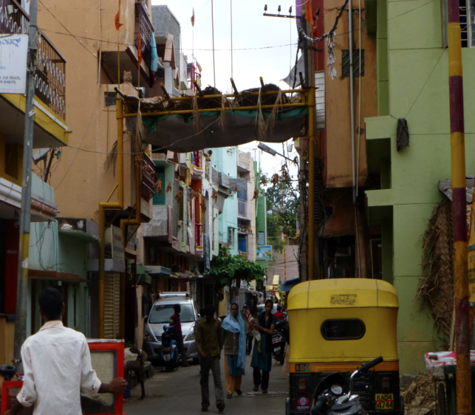

1. The practice of enumerating slum populations was commenced in the preceding census (of 2001), but this earlier exercise was confined only to considering slums located within the largest Indian cities.
2. See, for example, GOI (2010) and NSSO (2003, 2009).
3. We use interchangeably the terms “slum” and “low-income settlement.” Official documents usually utilize the former term, while academic discourse is divided on appropriate usage. For a more detailed discussion on terminology, see Roy, et al. (2013), esp. footnote 1.
4. Despite these data limitations, some notable investigations, using innovative methods, have examined longitudinal trends. See, for example, Bapat (2010); Bhatia and Chatterjee (2010); Krishna (2013); Mitra (2010); and Ramachandran and Subramanian (2001).
5. The initial breakthroughs on developing this satellite-image based methodology of slum identification were made by two Duke University students, Andrew Leon Hanna and Grady Lenkin, each of whom spent several weeks in Bangalore.
6. See, for example, Kit, Ludecke, and Reckien (2013); Livengood and Kunte (2012); and Sudhira, Ramachandra and Jagadish (2004).
7. Rather than considering what is colloquially known as Greater Bangalore (which extends over a wider and fast-expanding area, covering in addition to the BBMP’s jurisdiction several smaller peri-urban areas), we selected to focus initially on a well-identified area constituting the core of this city. Our methodology can be extended to Greater Bangalore at a later stage
8. These quadrants were numbered going counter-clockwise starting from the northeast and using the "ruler" feature of Google Earth to find the midpoints of each line segment and the "line" feature to draw the quadrant boundaries.
9. We refer to “blocks” instead of houses because there is no way of determining based on Google Earth satellite images how many housing units are included within a visible block.
10. The reason that “narrow inner roads” serves only as a supporting criteria is because it is so difficult to detect and because it is in many ways a function of the “lack of space between houses” criteria.
11. While plastic sheets similar to the blue roofing sheets are available in multiple colors, blue sheets are the least expensive and most commonly available, thus most extensively used.
12. Household and neighborhood schedules used for the earlier survey in notified slums are nearly identical to the ones used later for the blue-polygons surveys.
13. Personalized and informal connections predominate as well in slums of Delhi, as Jha, et al. (2007) and Mitra (2006) have separately documented. Summarizing his evidence, Mitra (2006: 2126) concludes that “in accessing the present occupations informal networks or contacts operating through relatives and other kinship bonds have played a major role… Apart from immediate relatives no other source of contact appears to be of any significance.” Less than two percent of slum dwellers were assisted in their job search by any NGO, and less than one percent took help from a private consultant. Non-institutional means of gaining information and access were utilized by more than 95 percent. Studying slum communities in Dhaka, the capital city of Bangladesh, Banks (2008) found similarly how social networks can matter more than level of education.
14. See, for example, the report of a high-level committee of the Indian government, which begins by assuming that cities “are the reservoirs of skills, capital and knowledge. They are the centers of innovation and creativity. They are the generators of resources for national and state exchequers. They are also the hopes of millions of migrants from the rural hinterland and smaller settlements. With growth of the services sector and surge of the knowledge economy, the population pressure on cities is bound to escalate” (GOI 2010: 1).
15. A similar point is made in respect of low-income settlements in Bangladesh by Roy, et al. (2013).